Image Based Automation

Introduction

The branch of Computer Vision deals with the goal of investigating the scientific principles underlying the construction of integrated vision systems and the application of vision to problems of real-world importance. As a scientific discipline, computer vision is concerned with the theory for building artificial systems that obtain information from images. The image data can take many forms, such as a video sequence, views from multiple cameras, or multi-dimensional data from a medical scanner. The emphasis of our work is on vision systems that are capable of functioning flexibly and robustly in complex changing environments.

Objective:

Our aim was to build a prototype of a computer controlled navigator that, with the help of an overhead/on-board camera and a computer tries to perform certain task. To demonstrate dexterity and precision required for industrial tasks we have designed the robot to put a ball in a hole that too by segregating them on the basis of colors.

Basic Block Diagram:

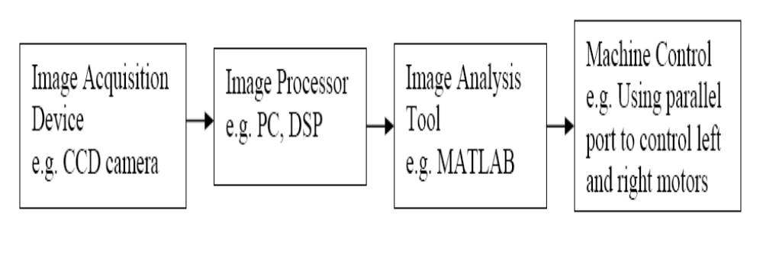

The block diagram above shows the basic system architecture.
The processor speed influences the response of the system. The algorithms are processed on the acquired image and using simple parallel or serial interface navigator is controlled.

• The pictures taken from Digital camera are shown in the Figure 1 and 2.

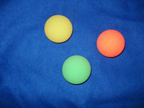 | 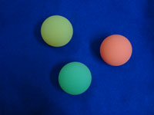
Figure 1 | Figure 2

All the codes are written in MATLAB.
Basic Algorithm:
Step 1: After connecting the overhead camera and RS232 serial interface
Initialize the video and serial interfaces by creating there respective
Objects. Initialize all the variables required in the program.
Step 2: Start the video object and take a snapshot of the arena for further
Processing. After getting the snapshot down sample the acquired
Image. The down sampled snapshot of the field is as shown:
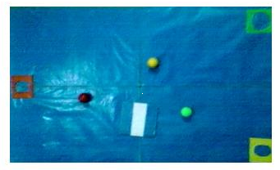
Step 3: In this step, the bot is extracted from the figure along with its
Centroid and orientation. After extracting the bot, the centroids of
All balls are calculated along with the positions of holes.
Step 4: Once the bot and ball properties are known, the ball which is closest
To the bot is determined.
Step 5: After knowing the closest ball the angle between the centroids of bot
And the closest ball is determined. This is the angle by which the bot
Has to rotate to orient itself along the ball.
Step 6: After knowing the angle the bot orients itself to the ball. Once it
Get oriented, it evaluates its head position by moving forward in the
Oriented position. If by moving forward the distance between ball
And bot increases, it rotates through 180 degree so that its front side
Points at the ball.
Step 7: After step 6, the bot heads along the ball till a predefined threshold
Distance between the bot and ball. During this path the bot orients
Itself after every two steps if it gets disoriented.
Step 8: After the bot gets to the ball it captures it by putting a ring around it.
Once it captures the ball it orients itself to the respective color of
Hole in the same way it did for the ball and puts the ball in that hole.
Step 9: The above steps from 1 to 8 repeat till all the balls are put in there
Respective holes.
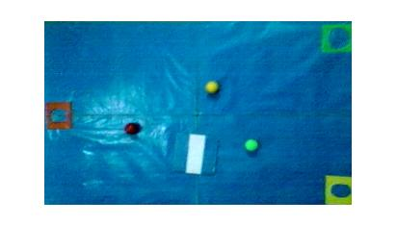

Original image

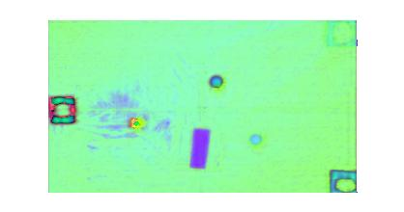
HSV conversion

Separation of Color planes.
